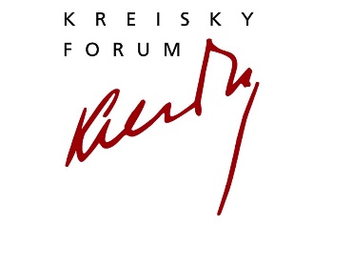
PHILOXENIA/EuropeIsAWoman. Curated by Tessa Szyszkowitz
Online Live Talk, Friday, April 9, 2021, 19.00 CET
Bruno Kreisky Forum für internationalen Dialog | Armbrustergasse 15 | 1190 Wien
Register: www.kreisky-forum.org

Tessa Szyszkowitz in conversation with Elif Shafak
HÖRT EINANDER ZU!
How to stay sane in a world of division

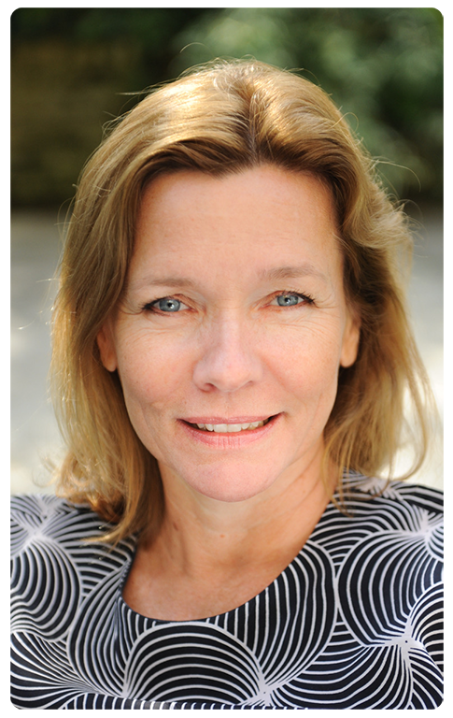
Elif Shafak is one of the most important intellectual voices in the pan-European debate about identity, multiculturalism, gender equality and free speech. In her latest pamphlet “How to stay sane in an age of division” - in German published in March 2021 under the name “Hört einander zu!” - the Turkish-British author and activist dissects the angers and anxieties of contemporary society in order to find methods to deal with the deepest divisions in this age of social media. The promise of social media to give everyone a voice has turned into the fear of having created a monster which is especially threateningly violent - certainly verbally - to women. Shafak sings the praise of complex thinking over believing in simple solutions. And she asks to channel anger into a productive force. Her plea is to stop shouting and start listening to each other.

Elif Shafak, is an award-winning Turkish- British novelist. She writes in both Turkish and English, and has published 18 books, 11 of which are novels. Her work has been translated into 54 languages. Her latest novel 10 Minutes 38 Seconds in this Strange World was shortlisted for the Booker Prize and RSL Ondaatje Prize; and chosen Blackwell’s Book of the Year. Her previous novel, The Forty Rules of Love was chosen by BBC among 100 Novels that Shaped Our World. Shafak holds a PhD in political science and she has taught at various universities in Turkey, the US and the UK, including St Anne's College, Oxford University, where she is an honorary fellow. Shafak is a Fellow and a Vice President of the Royal Society of Literature. She is a member of Weforum Global Agenda Council on Creative Economy and a founding member of ECFR (European Council on Foreign Relations).

Hört einander zu! , Übersetzung: Michaela Grabinger, erscheint am 16. März 2021 bei Kein & Aber. ISBN: 978-3-0369-5844-6

Tessa Szyszkowitz, Historian, Journalist and Author; UK-Correspondent for PROFIL, Falter und Cicero. She is also Senior Associate Fellow at Royal United Services Institute in London.

Das Programm des Bruno Kreisky Forums für internationalen Dialog wird mit Unterstützung der Stadt Wien, der Republik Österreich (Bundeskanzleramt, Bundesministerium für Bildung, Wissenschaft und Forschung, Bundesministerium für Landesverteidigung) und mit Hilfe privater Sponsoren und Spender realisiert. Wir danken all unseren Förderern und unseren zahlreichen Partnern und Partnerinnen für die gute Zusammenarbeit.
