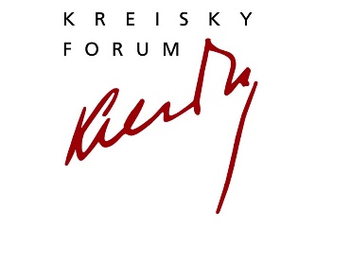
PHILOXENIA. Curated by Tessa Szyszkowitz
Online Live Talk, Tuesday, May 4, 2021, 19.00 CET
Bruno Kreisky Forum für internationalen Dialog | Armbrustergasse 15 | 1190 Wien
Register: www.kreisky-forum.org

Tessa Szyszkowitz in conversation with Anthony Barnett
THE LURE OF GREATNESS – AND SMALLNESS
How the EU should deal with China and Scotland

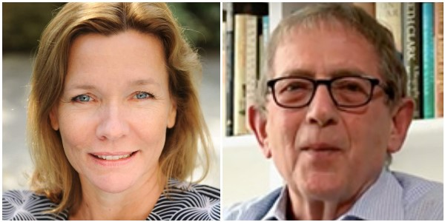

Since his last book “The Lure of Greatness” was published in 2017, British democracy activist Anthony Barnett has had to endure watching both his country go through a hard Brexit and the presidency of Trump. The consequences are now beginning to show. The US has been able to evict its one-time president, despite his followers storming the Capitol, while Brexit will not be easily reversed. The co-founder of openDemocracy has just published on it a long essay on the significance of the forces that elected Joe Biden ‘The End of Closed Democracy?’. He also tries to watch the development of the European Union. How will an EU weakened by the exit of the UK, but maybe more flexible because of it, respond to the rivalry between the US and China? The one a new, aggressive upcoming superpower in the East, the other its old ally seeking to re-establish its global hegemony. And what will happen to the UK? A surprising connection between the two questions is a third, how will the European Union react to the “Lure of Smallness” in the north of the United Kingdom? If Scotland decides after its elections on May 6th to push for independence in a new referendum – should the European public welcome Scotland back as an EU-member state? And would this spell the end of the Brexit project?
Anthony Barnett is the co-founder of Open Democracy. A former member of the editorial committee of New Left Review, Barnett also writes occasionally for The Guardian and regularly for Byline Times. A campaigner for democracy, he was the first Director of Charter 88 from 1988 to 1995. In 2001 he was the launch editor of openDemocracy and remains a regular contributor. In 2016, it serialised his “Blimey it could be Brexit!” publishing a chapter a week in the run up to Britain's EU referendum about the forces behind the vote. His in-depth evaluation was published under the title The Lure of Greatness: England’s Brexit and America’s Trump. Barnett was awarded an honorary doctorate from The Open University in September 2013 and Goldsmiths University in 2019.
Tessa Szyszkowitz, Historian, Journalist and Author; UK-Correspondent for PROFIL, Falter und Cicero. She is also Senior Associate Fellow at Royal United Services Institute in London.

Das Programm des Bruno Kreisky Forums für internationalen Dialog wird mit Unterstützung der Stadt Wien, der Republik Österreich (Bundeskanzleramt, Bundesministerium für Bildung, Wissenschaft und Forschung, Bundesministerium für Landesverteidigung) und mit Hilfe privater Sponsoren und Spender realisiert. Wir danken all unseren Förderern und unseren zahlreichen Partnern und Partnerinnen für die gute Zusammenarbeit.
